Exercise 1: Setting Up Junit

Step 1: creating a project using Maven

Step 2: adding Junit 5 dependency to the pom.xml file :

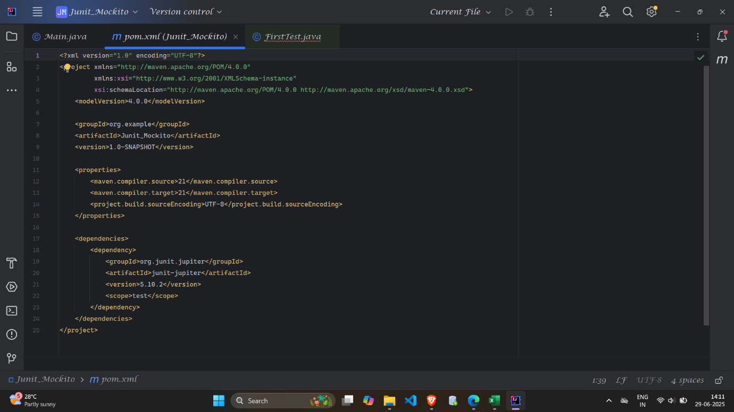

Step 3: creating a new test class – FirstTest and running the first unit testing

